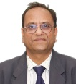
Editor in Chief: Dr. Chandrakant Bonde
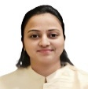
Editor: Ms. Hemangi Rathod
It gives us immense pleasure to present this edition of the SSR College of Pharmacy newsletter — a reflection of the vibrant academic, research, and co-curricular activities that continue to shape our institution.
At SSR College of Pharmacy, we are committed to fostering innovation, critical thinking, and ethical responsibility in the field of pharmaceutical sciences. This issue highlights some of the recent achievements of our students and faculty, academic collaborations, seminars, workshops, and community outreach initiatives that continue to inspire growth and excellence.
Our college remains dedicated to nurturing future pharmacists who are not only skilled and knowledgeable but also socially responsible contributors to healthcare. We applaud the consistent efforts of our students, faculty members, and alumni who make SSR College of Pharmacy a hub of academic brilliance.
We hope this edition serves as a source of pride, motivation, and information for our readers. We look forward to your continued support and contributions in making each edition more engaging and impactful.
Warm regards,

EDITORIAL BOARD

- Dr. Smita Bonde


- Dr. Sonal
Desai


- Dr. Himanshu
Solanki


- Dr. Parixit Prajapari

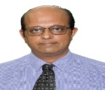
- Mr. Vipul Prajapati


- Dr. Lata Manani

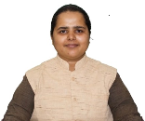
- Ms. Priya Shukla

Pharma Sprint 2025–26 | Sports Newsletter

🏃‍♂️ PharmaSprint 2025–26

Celebrating Fitness, Teamwork & Sportsmanship
PharmaSprint 2025–26, the annual sports and fitness event of SSR College of Pharmacy, was organized to promote physical well-being, teamwork, and a balanced academic lifestyle. The event embodied the spirit of speed, strength, stamina, and unity, providing students with a vibrant platform to showcase their athletic talent and sportsmanship through a variety of indoor and outdoor competitions.

🏆 Major Event Results
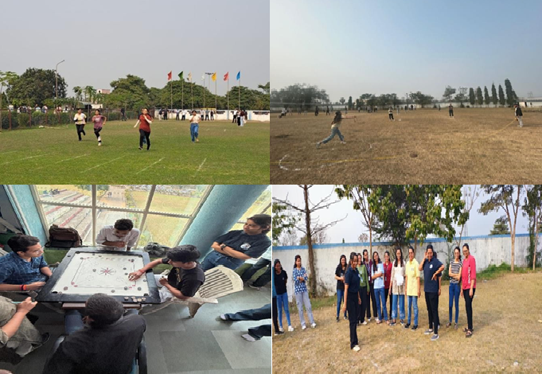
🏏 Cricket (Boys)
Winners: Final Year B. Pharm
Captain: Darshan Pawar
🏏 Cricket (Girls)
Winners: Final Year B. Pharm
Captain: Tisha Patel
🏐 Volleyball (Boys)
Winners: Final Year B. Pharm
Captain: Aman
🥇 Shot Put
- Boys: 1st Abhishek Thakur | 2nd Khushraj Patel | 3rd Kiran Kale
- Girls: 1st Vaishnavi Dhumal | 2nd Sonali Rajat | 3rd Mansi Patel
🥏 Discus Throw
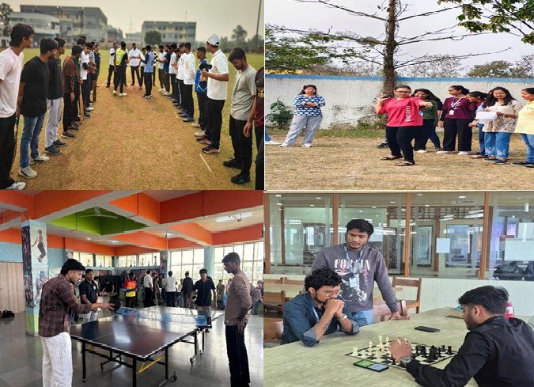
- Boys: 1st Abhishek Thakur | 2nd Vivek | 3rd Mrummay
- Girls: 1st Vaishnavi Dhumal | 2nd Riya Nishad | 3rd Sonali Rajak
🏓 Table Tennis
Winners: Omkar Sark | Bibek Behera | Kevin Jadhiya
♟️ Chess
1st Yash Tailor | 2nd Vivek Borana | 3rd Vishaka Patil
🎯 Carrom (Girls)
1st Apeksha Shinde | 2nd Khushi Mohile & Rajpal | 3rd Chandrashekar, Saad & Yogesh
🏃 100 m Race
- Boys: 1st Afif | 2nd Sandesh | 3rd Alok P
- Girls: 1st Sonali | 2nd Pragya | 3rd Aniska

🚑 Safety Support
A dedicated First Aid Team led by Ms. Priya Shukla ensured continuous medical assistance during the event on 30–31 January 2026.

🏅 Prize Distribution
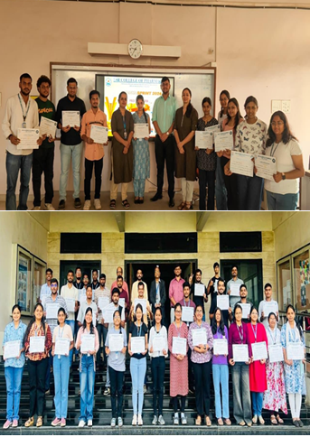

The Prize Distribution Ceremony was held on 2 February 2026, where the Principal and faculty members felicitated winners with medals and trophies. The ceremony highlighted the importance of fitness, teamwork, and maintaining a healthy balance between academics and sports.
✨ PharmaSprint 2025–26 successfully strengthened the spirit of unity, resilience, and sportsmanship among students, reinforcing the belief that a healthy body nurtures a healthy mind.

Mega Medical Camp
On 1st February 2026, students of SSR College of Pharmacy actively participated as Pharmacist Volunteers in a Mega Medical Camp organized in collaboration with Lions Club Silvassa. The camp aimed to provide accessible healthcare services to the community and promote health awareness among the general public.
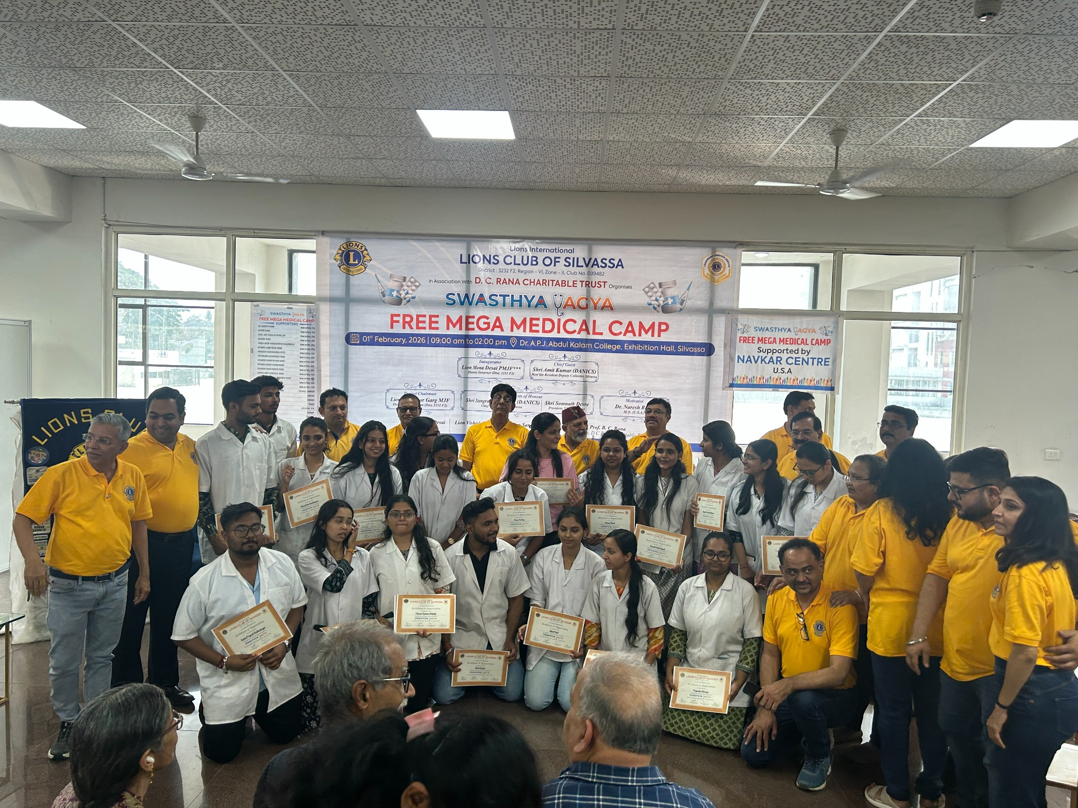
Our pharmacy students played a vital role in the smooth functioning of the camp. They assisted in dispensing medications under the supervision of registered pharmacists and doctors, explained dosage instructions to patients, ensured proper labeling, and maintained systematic distribution of medicines. Students also supported patient registration and prescription handling.
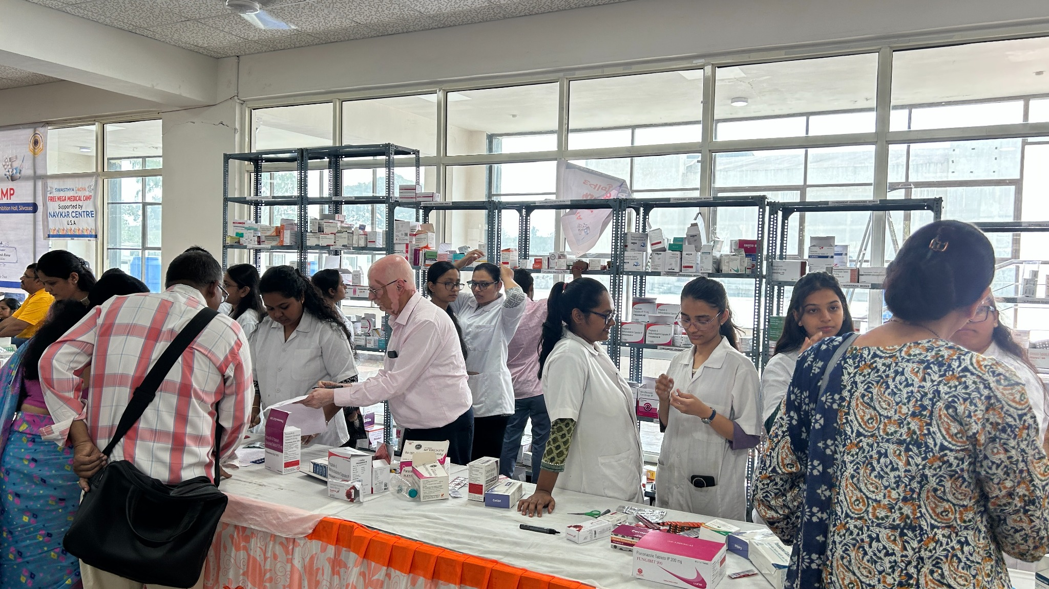
The camp witnessed a large turnout of beneficiaries who received free medical consultations, basic diagnostic services, and essential medicines. This initiative provided students with valuable hands-on experience in community pharmacy practice and strengthened their professional competence and social responsibility.
The management and faculty of SSR College of Pharmacy express sincere gratitude to Lions Club Silvassa for providing this opportunity to serve society. The event was a great success and reflected the institution’s commitment to community engagement.

Industrial Visit Program
Pharmacy Students Visit Leading Pharmaceutical Industries
To strengthen practical understanding and provide industrial exposure beyond classroom learning, SSR College of Pharmacy, III Cell organized educational industrial visits for pharmacy students across different academic years during February 2026. These visits were designed to familiarize students with pharmaceutical manufacturing processes, quality systems, regulatory standards, and professional practices followed in leading pharmaceutical industries.
Visit to J&B Chemicals
On 06 February 2026, 65 students of First Year B.Pharm and First Year M.Pharm visited J&B Chemicals. During the visit, students were introduced to the fundamentals of pharmaceutical manufacturing, including raw material handling, production processes, packaging procedures, and quality control practices. Industry experts explained the importance of standard operating procedures, safety measures, and quality assurance followed within the facility.
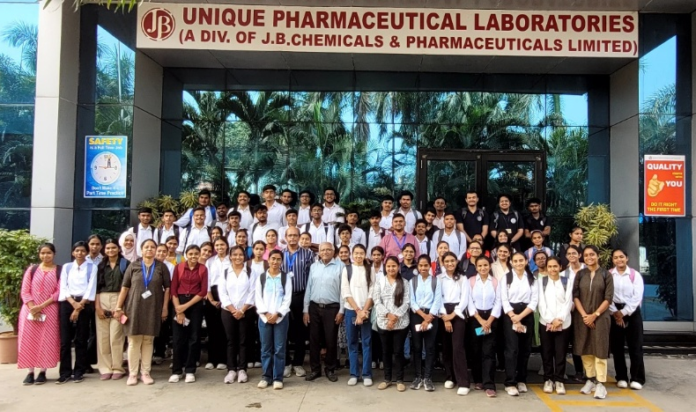

Visit to IPCA Laboratories
On 07 February 2026, 60 students of Third Year B.Pharm visited IPCA Laboratories. The visit provided practical exposure to advanced pharmaceutical manufacturing techniques, laboratory operations, and industrial quality assurance systems. Students observed industrial equipment and gained valuable understanding of large-scale pharmaceutical production and compliance requirements.
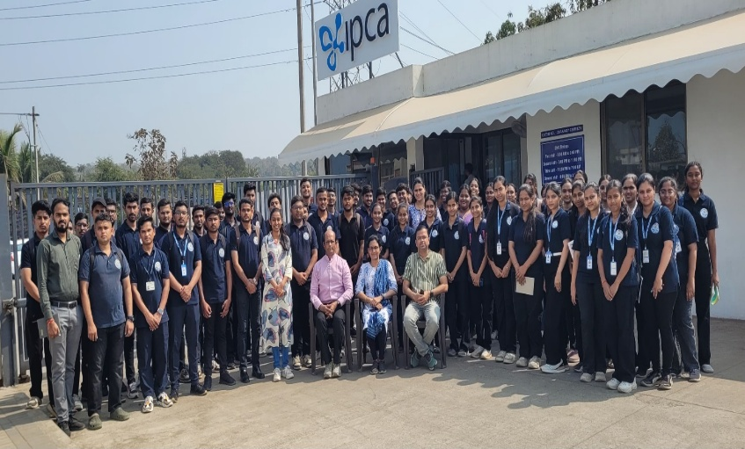

Visit to Sun Pharmaceuticals
On 07 February 2026, 55 students of Final Year B.Pharm visited Sun Pharmaceuticals. This visit focused on modern pharmaceutical production systems, industrial workflow, regulatory compliance, and technological advancements adopted in the pharmaceutical sector. Students also interacted with professionals to understand industrial expectations and career opportunities.
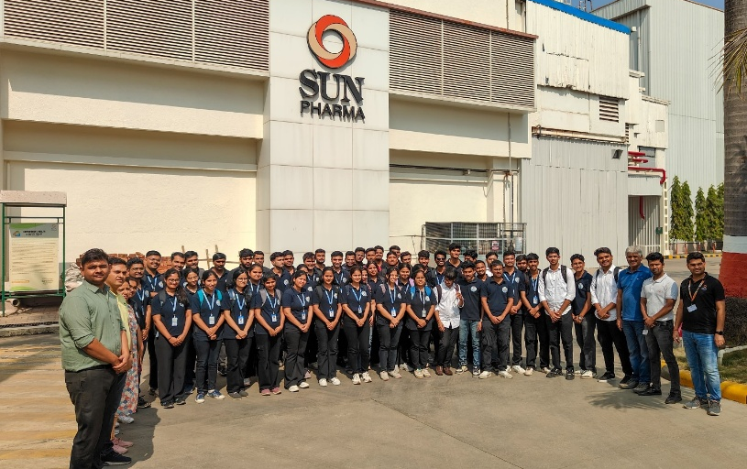

Learning Outcomes
- Practical exposure to pharmaceutical manufacturing processes
- Understanding of quality assurance and quality control systems
- Awareness of industrial safety standards and regulatory compliance
- Interaction with pharmaceutical industry professionals
Faculty Coordinators
The industrial visits were successfully conducted under the guidance of Mr. Vipul Prajapati, Ms. Avni Desai, Ms. Ankita Das
Such industrial visits play a significant role in bridging theoretical knowledge with industrial practice and help students develop professional awareness required for future careers in the pharmaceutical field.

🌟Cultural Fest Days Celebration 2026 🌟
20th & 21st February 2026 | Pharmacy Campus
Savitribai Phule Pune University
SSR College of Pharmacy joyfully celebrated a vibrant two-day Cultural Fest 2026 on 20th and 21st February 2026 within the pharmacy campus. The celebration was organized with the objective of promoting creativity, teamwork, cultural awareness, and holistic development among students. The event fostered unity, enthusiasm, and artistic expression, creating unforgettable memories for all participants.

🎬 Day 1: Bollywood Hungama / Retro Day
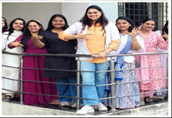
20th February 2026
Day 1 transformed the campus into a colorful hub of Bollywood glamour and retro charm. Students enthusiastically participated in various competitions, showcasing creativity, talent, and confidence beyond academics.

🌟 Best Outfit Award (Male/Female)
Participants dazzled the audience with Bollywood and retro-inspired attire. Judging criteria included creativity, presentation, and confidence, encouraging expressive stage presence.

🗺️ Treasure Hunt Competition
A thrilling team-based challenge that tested analytical thinking, coordination, and teamwork. Clues and tasks spread across the campus added excitement and healthy competition.

🥗 Salad Decoration Competition
Students exhibited creativity and nutritional awareness by designing visually appealing and healthy salad platters, blending aesthetics with health consciousness.
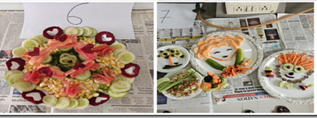
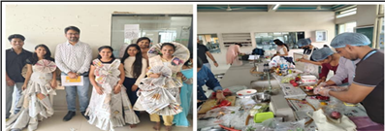

👗 Paper Dressing Competition
Teams crafted innovative outfits using paper materials, demonstrating exceptional imagination, coordination, and resourcefulness.

🎤 Singing Competition
Melodious Bollywood and retro performances filled the campus with rhythm and harmony. Students and faculty members actively participated, making the event even more special.

💃 Dancing Competition
Energetic solo and group dance performances captivated the audience. Vibrant costumes and lively retro beats created an electrifying atmosphere.

👑 Day 2: Roots & Royalty – Traditional Day
21st February 2026
The second day celebrated India’s rich cultural heritage and traditions, highlighting elegance, diversity, and artistic skills.

👑 Cultural Couture Award (Male/Female)
Students represented various regions of India through traditional attire. The event celebrated authenticity, heritage, and confident presentation.

💇 Hairstyle Competition
Participants showcased creative and traditional hairstyling skills, reflecting grooming expertise and artistic talent.

🎭 Ad-Mad Show
Teams performed humorous and innovative advertisements for real or imaginary products. The activity enhanced creativity, communication, and marketing skills.

🚶 Ramp Walk (Male/Female)
One of the fest’s highlights, the Ramp Walk showcased confidence, elegance, and poise as participants walked the ramp in traditional attire.

🏆 Prize Distribution Ceremony
The Cultural Fest concluded with a grand Prize Distribution Ceremony. Winners were honored with certificates and prizes in recognition of their outstanding performances. The Principal appreciated the enthusiastic participation of students and the Cultural Fest 2026 was a grand success, marked by vibrant participation, teamwork, and cultural celebration. The event strengthened unity, creativity, and cultural appreciation among students while creating cherished memories for the entire college community.

🎪 Young Maker’s Carnival 2026
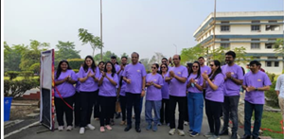College of Pharmacy organized the Young Maker’s Carnival 2026 on 19th February 2026 at the SSR Campus. The event was inaugurated with a ribbon-cutting ceremony by the Principal and witnessed enthusiastic participation from students and faculty members.
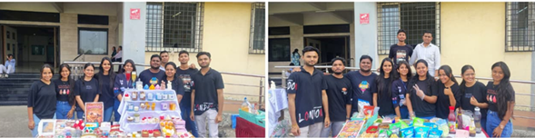
The carnival aimed to promote creativity, entrepreneurship, teamwork, and leadership skills beyond academics. The campus was beautifully decorated, creating a vibrant and festive atmosphere.

🍴 Food & Creative Stalls
Students managed themed food stalls such as Swadishta Panipuri, Pharmacy Chaat & Mojito, Bread Bar, and Chhat-Sip-Dip. Pricing pamphlets ensured transparency and budgeting skills. Creative stalls like Yarn Diaries, Shimmer and Smile, and a Scented Candle stall showcased crochet items, jewellery, and handmade products.
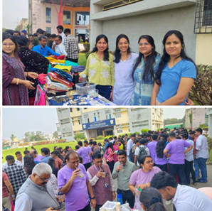

🎯 Game Stalls
Fun games including Ring Toss, Push-Up Game, 7 Up & 7 Down, and Spin & Win engaged participants, with prizes adding excitement to the event.
The carnival provided practical exposure in planning, financial management, marketing, and communication skills. Conducted smoothly under the guidance of faculty coordinators, the event was a grand success, fostering unity and memorable experiences for all.

Report on SPPU Startup Talk Series
SSR College of Pharmacy successfully organized the SPPU Startup Talk Series – “Conversations with Young Entrepreneurs” to encourage entrepreneurial thinking among pharmacy students. The program aimed to expose students to real-life startup journeys, business opportunities, and the practical aspects of entrepreneurship in the healthcare and pharmaceutical sectors.

Talk 1
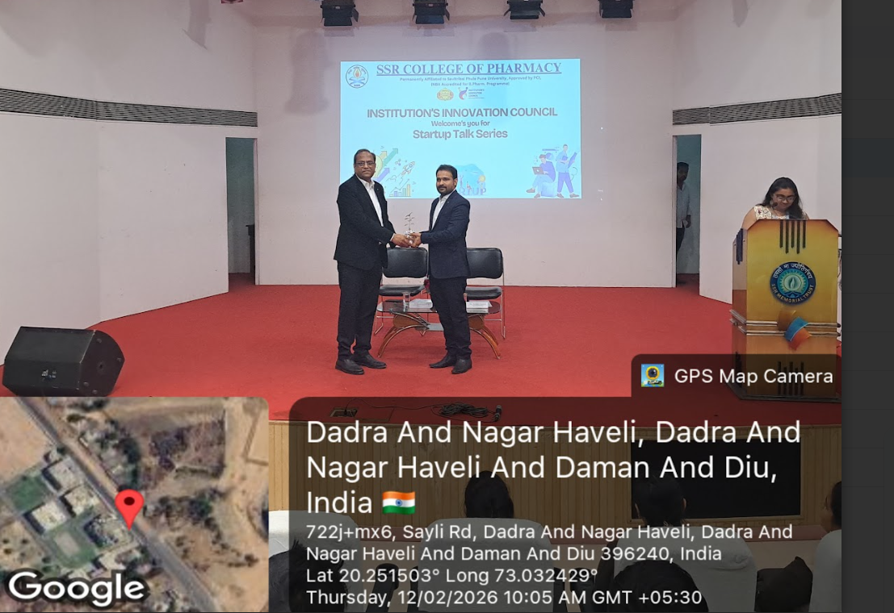
Date: 12 February 2026
Title: Entrepreneurial Pathways: From Startup Journey to Funding Success
Speaker: Dr. Neelabh Kaushik
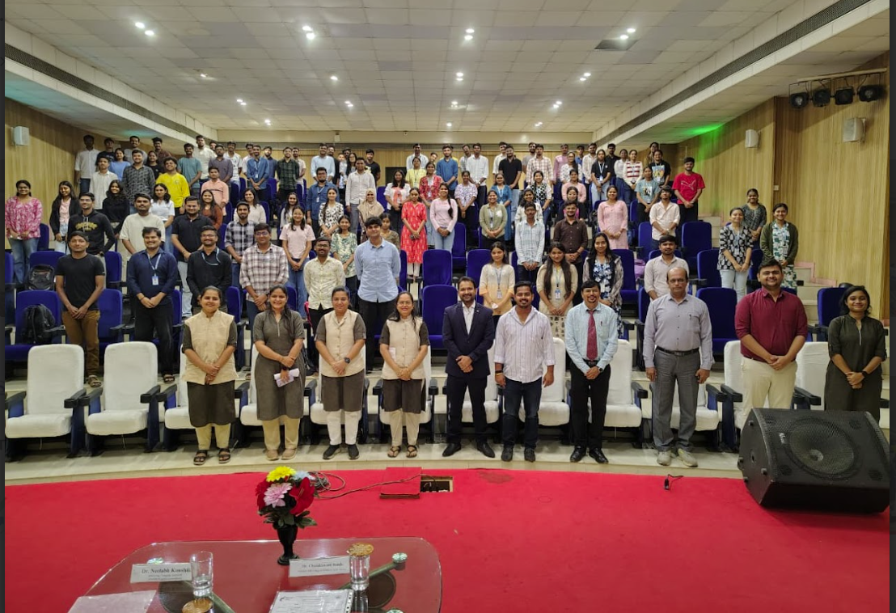
Dr. Neelabh Kaushik, a practicing Company Secretary and Management Consultant with over 14 years of professional experience, delivered an insightful session on startup development and funding strategies. He is the founder of Neelabh Kaushik & Associates, providing consultancy in corporate compliance, finance, taxation, and startup business structuring.
Dr. Kaushik holds multiple professional qualifications including Ph.D., CS, CMA, LLB, LLM, and MBA (Finance & Marketing). During the talk, he explained important aspects such as financial planning, corporate governance, startup feasibility studies, taxation planning, and investment strategies. He also discussed how entrepreneurs can convert innovative ideas into sustainable businesses by understanding regulatory frameworks and financial modeling.

Talk 2
Date: 25 February 2026
Title: From Idea to Enterprise: A Real-Life Startup Experience
Speaker: Mr. Yash Kiranbhai Prajapati
Mr. Yash Prajapati, a pharmacy professional and entrepreneur, shared his inspiring journey from academic research to running a healthcare business. He completed his M.Pharm in Pharmaceutics from SSR College of Pharmacy, where he conducted research on sustained-release matrix tablets.
He also gained industry exposure through internships at Sun Pharmaceutical Industries and Penta Pharmaceuticals. Currently, he serves as the Managing Director and Pharmacist at Jeevan Jyoti Medical & General Store, where he is actively involved in healthcare services and business management.
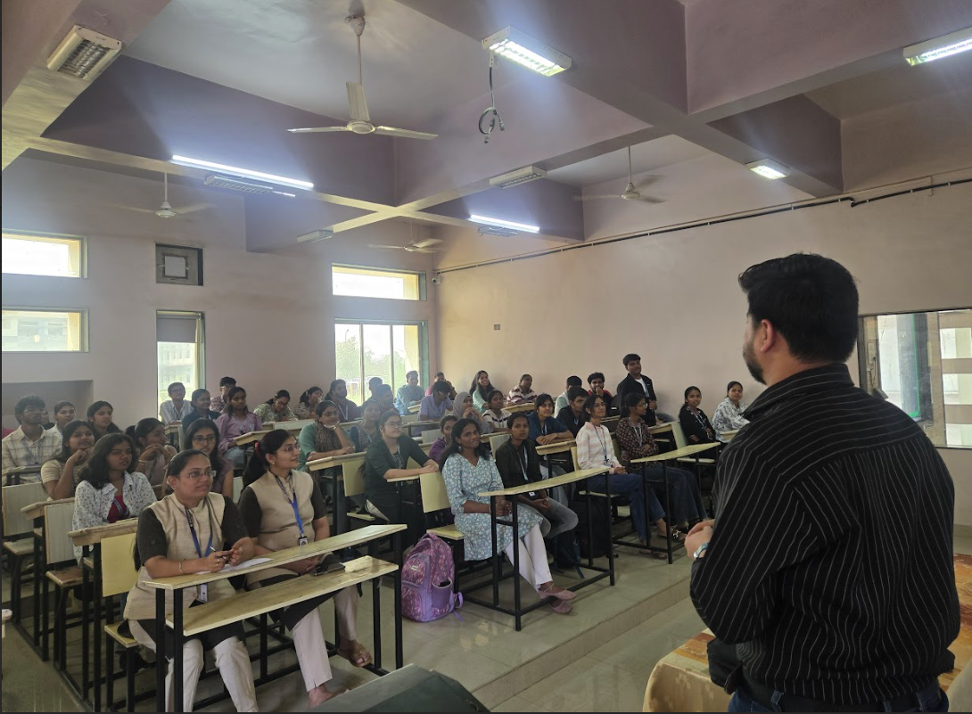
In his talk, he highlighted the practical challenges and opportunities in pharmaceutical entrepreneurship, motivating students to explore startup ideas in pharmacy practice, healthcare services, and drug development sectors.

Outcome and Impact
The Startup Talk Series provided students with valuable exposure to the startup ecosystem and entrepreneurial opportunities in the pharmaceutical sector. The speakers shared practical experiences regarding startup ideation, business planning, funding sources, legal requirements, and risk management.
Students actively participated in the interactive Q&A sessions, asking questions about startup registration, funding options, business risks, and innovation in healthcare enterprises. The sessions helped participants understand how pharmaceutical knowledge can be translated into successful healthcare ventures and entrepreneurial initiatives.
Overall, the program created awareness about entrepreneurship as a promising career path and inspired students to develop innovative, market-oriented ideas aligned with India’s growing startup ecosystem.
Meeting with Hon. Cabinet Minister Shri Kanubhai Desai
Dr. Chandrakant Bonde, Principal of SSR College of Pharmacy, along with the Convener and Co-convener of Pharma Anveshan 2026 from ROFEL Shri G.M. Bilakhia College of Pharmacy, met Shri Kanubhai Desai, Hon’ble Cabinet Minister of Finance, Urban Development and Urban Housing, Government of Gujarat, to extend a formal invitation for the upcoming Pharma Anveshan 2026 program on behalf of the Pharmacy Colleges of South Gujarat.
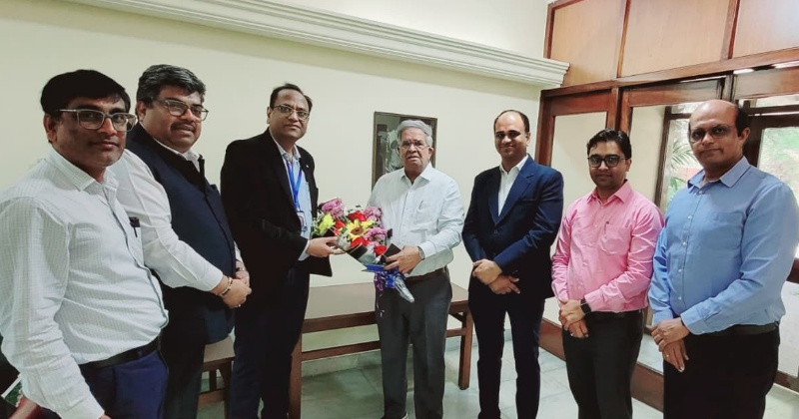
The meeting was organized with the collaborative support of ROFEL Shri G.M. Bilakhia College of Pharmacy, Smt. B.N.B. Swaminarayan Pharmacy College, and SSR College of Pharmacy. The interaction was very positive and fruitful, during which Shri Kanubhai Desai graciously accepted the invitation and conveyed his best wishes for the grand success of the Pharma Anveshan 2026 program.
International Women’s Day Celebration
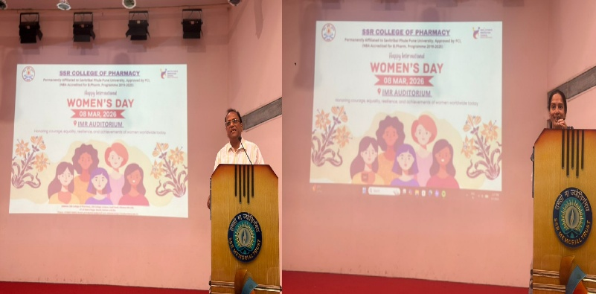
SSR College of Pharmacy proudly celebrated International Women’s Day 2026 on 7 March 2026 at 12:00 Noon in the IMR Auditorium. The program honored the strength, resilience, and achievements of women and highlighted the importance of gender equality and empowerment in society. Faculty members and students enthusiastically participated in the celebration, reflecting on the vital role of women in shaping education, healthcare, and the future of the nation.
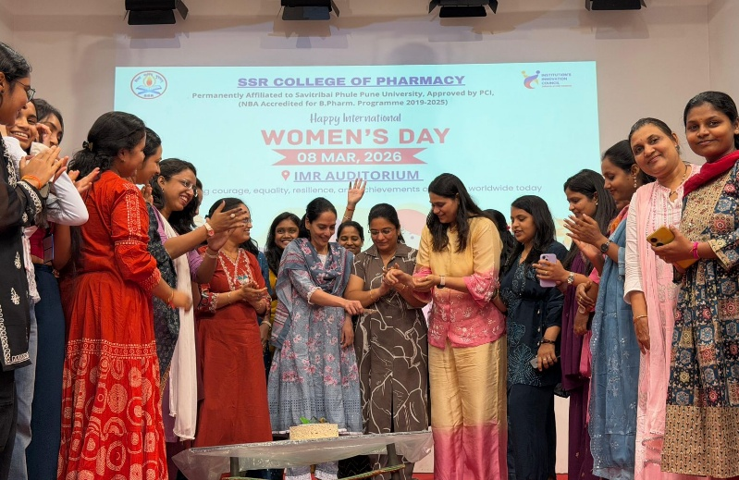
The event inspired everyone to continue supporting respect, opportunity, and empowerment for women in all spheres of life.
Pharmacy Council of India Inspection
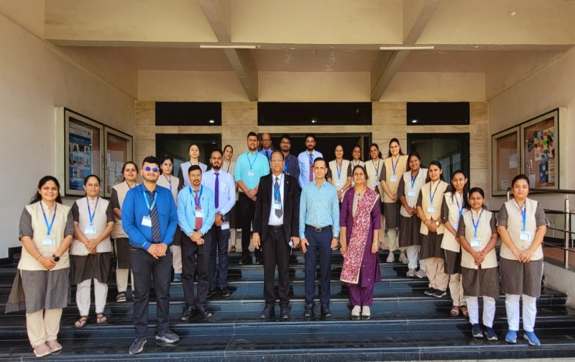
On 16th March, Pharmacy Council of India conducted an inspection visit at SSR College of Pharmacy to evaluate the institute’s academic standards, infrastructure, and compliance with regulatory norms. The inspection team reviewed key areas including laboratories, classrooms, library facilities, and teaching–learning processes, along with documentation related to faculty qualifications and student performance. The visit aimed to ensure that the institution maintains quality education and adheres to the standards prescribed by PCI. The management, faculty, and staff actively cooperated during the inspection, reflecting the college’s commitment to continuous improvement and excellence in pharmaceutical education.
Quality Council inspection
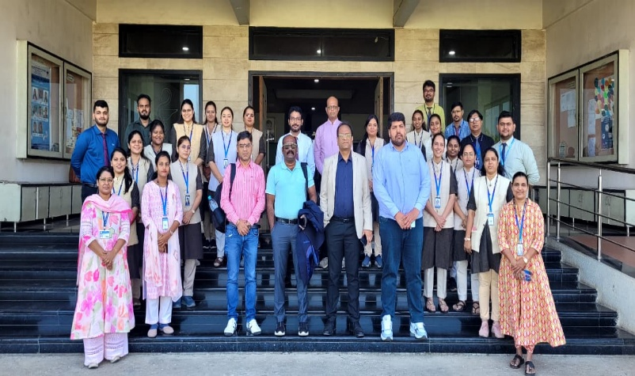
On 21st and 22nd March, a Quality Council inspection was conducted at SSR College of Pharmacy by the Quality Council of India to assess the institution’s quality standards in education, infrastructure, and overall academic practices. The audit team thoroughly evaluated teaching–learning processes, faculty credentials, laboratory facilities, documentation, and institutional governance. Special emphasis was given to quality assurance systems, student support services, and continuous improvement practices. The college administration, faculty, and staff extended full cooperation throughout the audit process, demonstrating their dedication to maintaining high standards and fostering excellence in pharmaceutical education.
Participation in Pharma Anveshan 2026
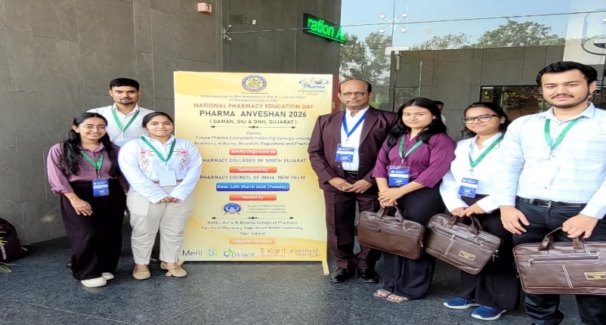
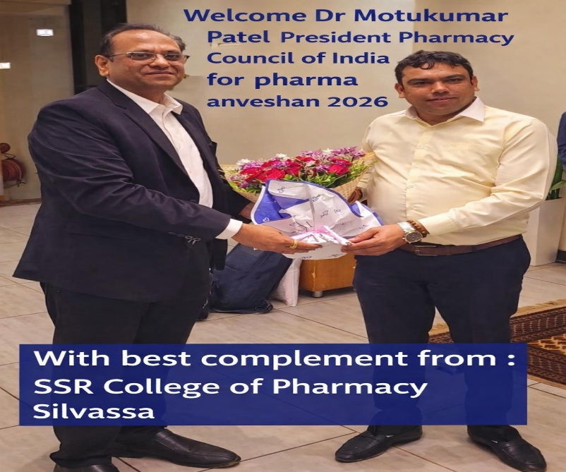
On 24th March 2026, faculty members and the Principal of SSR College of Pharmacy actively participated in Pharma Anveshan 2026, a prestigious academic and professional event organized under the theme “Future Pharma Ecosystem: Fostering Synergy among Academia, Industry, Research, Regulatory & Practice.”
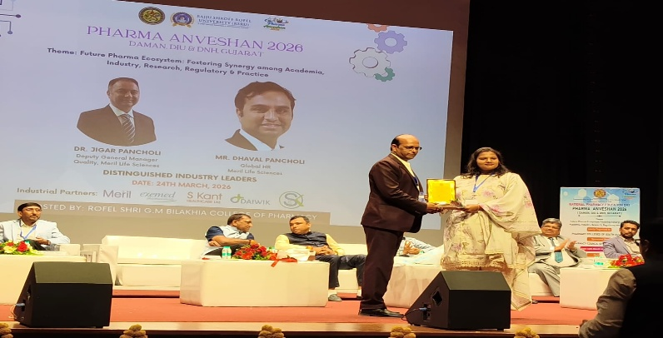
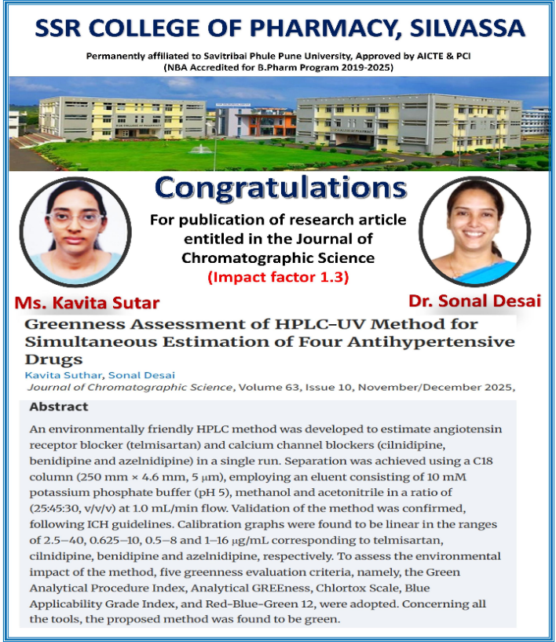
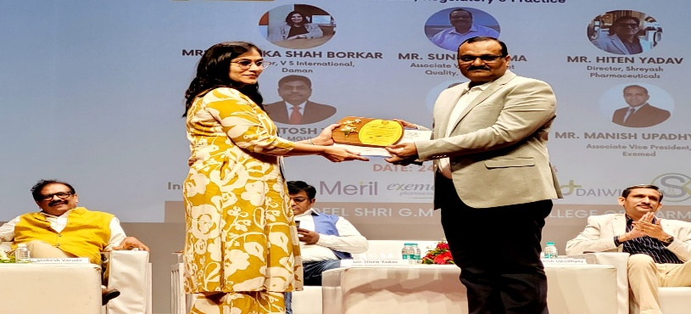The program included inaugural ceremonies, expert talks, panel discussions, and various concurrent sessions such as patent presentations, innovative product displays, and startup pitching. The enthusiastic involvement of SSR College faculty and leadership in technical sessions, discussions, and networking activities highlighted their commitment to academic excellence, innovation, and collaboration with industry and regulatory bodies, contributing significantly to the success of the event.

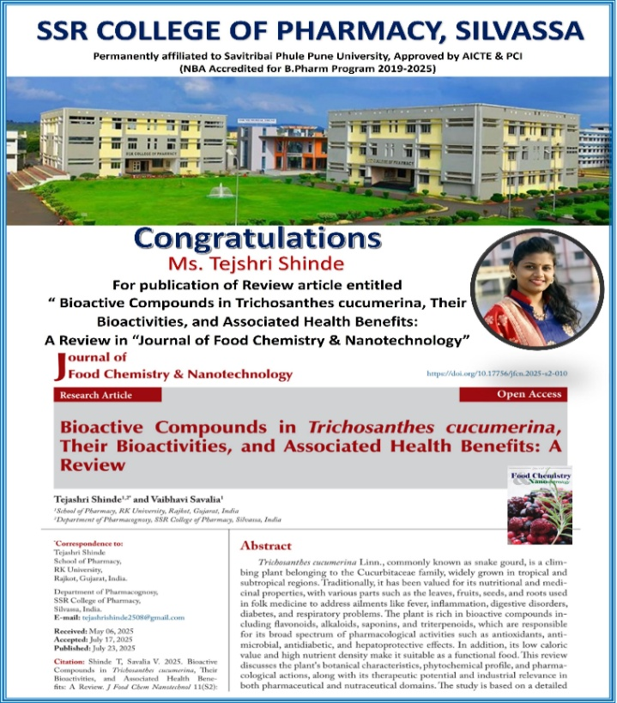
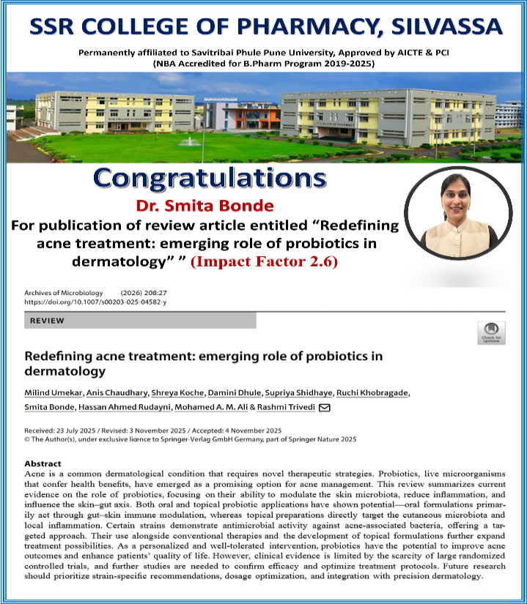
Publications and Award

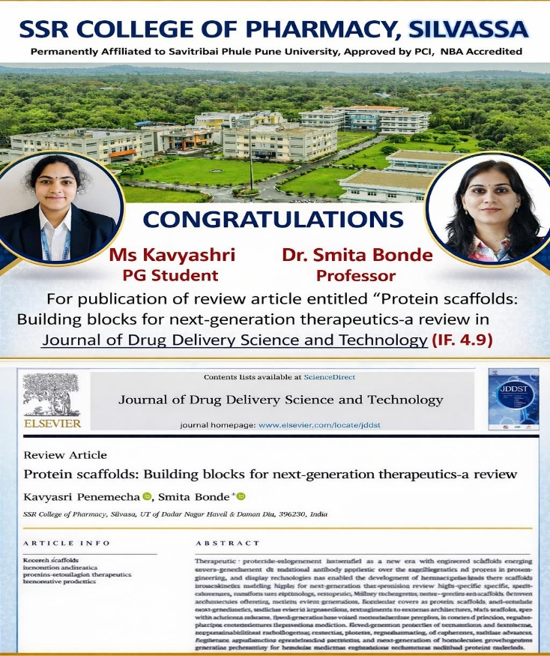
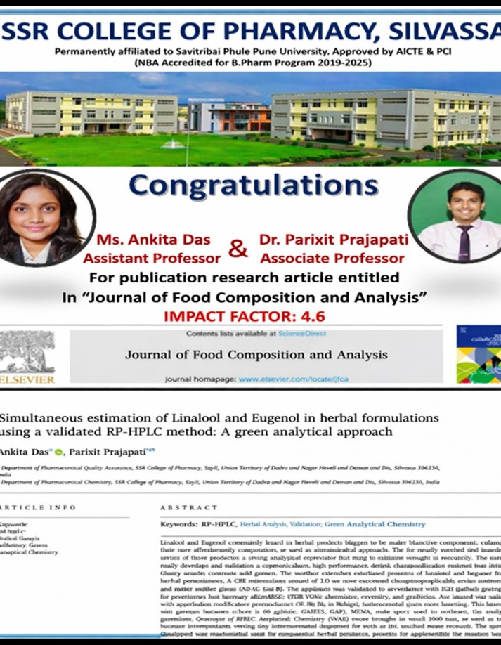
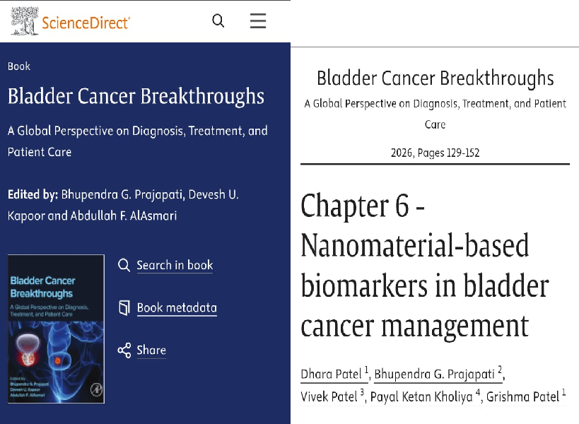
Book Chapters by Faculty
We are proud to highlight the scholarly contribution of Mrs. Payal Ketan Kholiya as a co-author of Chapter 6 titled “Nanomaterial-based Biomarkers in Bladder Cancer Management” in the book Bladder Cancer Breakthroughs: A Global Perspective on Diagnosis, Treatment, and Patient Care (2026). This chapter provides valuable insights into the emerging role of nanotechnology in improving the diagnosis and management of bladder cancer, focusing on advanced biomarker systems that enhance early detection, precision, and treatment outcomes. Her contribution reflects dedication to research excellence and innovation in the field of pharmaceutical and biomedical sciences, bringing recognition to both the academic community and the institution.

